**3COM CORPORATION**

ETHERLINK II (3C503; ASSY.#7920)

|  |  |
| --- | --- |
| **NIC Type** | Ethernet |
| **Transfer Rate** | 10Mbps |
| **Data Bus** | 8-bit ISA |
| **Topology** | Star |
| **Wiring Type** | RG58A/U 50ohm coaxial  AUI transceiver via DB-15 port |
| **Boot ROM** | Available |

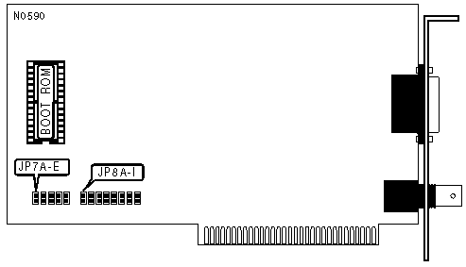

|  |  |  |  |  |  |  |
| --- | --- | --- | --- | --- | --- | --- |
| **BOOT ROM ADDRESS** | | | | | | |
| **Address** | | **JP7A** | **JP7B** | **JP7C** | **JP7D** | **JP7E** |
| » | Disabled | Closed | Open | Open | Open | Open |
|  | C8000h | Open | Closed | Open | Open | Open |
|  | CC000h | Open | Open | Closed | Open | Open |
|  | D8000h | Open | Open | Open | Closed | Open |
|  | DC000h | Open | Open | Open | Open | Closed |

|  |  |  |  |  |  |  |  |  |  |
| --- | --- | --- | --- | --- | --- | --- | --- | --- | --- |
| **I/O BASE ADDRESS** | | | | | | | | | |
| **Address** | | **JP8A** | **JP8B** | **JP8C** | **JP8D** | **JP8E** | **JP8F** | **JP8G** | **JP8H** |
|  | 250h | Open | Open | Open | Open | Closed | Open | Open | Open |
|  | 280h | Open | Open | Open | Open | Open | Closed | Open | Open |
|  | 2A0h | Open | Open | Open | Open | Open | Open | Closed | Open |
|  | 2E0h | Open | Open | Open | Open | Open | Open | Open | Closed |
| » | 300h | Closed | Open | Open | Open | Open | Open | Open | Open |
|  | 310h | Open | Closed | Open | Open | Open | Open | Open | Open |
|  | 330h | Open | Open | Closed | Open | Open | Open | Open | Open |
|  | 350h | Open | Open | Open | Closed | Open | Open | Open | Open |

**3Com Corporation**

**EtherDisk Diskette for the EtherLink II Adapters**

**System Resources**

**Listed below are commonly used peripherals and their option settings. If any**

**of these peripherals are installed in your computer, check which resources**

**they are using and make sure that the software options on the EtherLink II**

**adapters are not set to use the same resources. Other peripherals not**

**mentioned in these lists could also cause conflicts.**

**I/O Base Address Device**

**---------------- ------**

**200 Game I/O adapter**

**270 LPT2: second parallel port**

**2F0 COM2: second serial port**

**320 Fixed disk adapter**

**370 LPT1: primary parallel port**

**380 Monochrome display adapter**

**3C0 Enhanced graphics adapter**

**3D0 Color graphics adapter**

**Interrupt Level Device**

**--------------- ------**

**IRQ3 COM2**

**IRQ4 COM1**

**IRQ5 LPT2**

**IRQ7 LPT1**

**Memory Usage**

**------------**

**Address Device**

**C0000-C3FFF EGA BIOS**

**C0000-C8000 Normal VGA area**

**C8000-CBFFF Hard disk adapter BIOS**

**D0000-DFFFF EMS swap area (page frame)**

**(%VER System Resources v3.4b)**